Living without Housing in Okanogan County Social Media Kit
Proposed Post Date | Image | Content | Proposed link for more information. Agencies could also use their own website links.
12-21-22 | 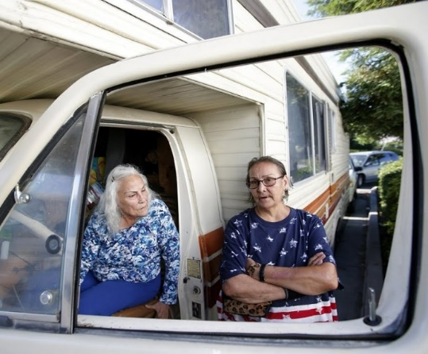 | First Day of Winter Marks National Homeless Persons Memorial Day  Do you know between 70-80 percent of people living without permanent housing in Okanogan County are local or have lived in the community for over a year?  The Okanogan County Housing Authority is launching a social media campaign called The Face of Homelessness in Okanogan County to help raise awareness of what people in our community who live without permanent housing face every day. Start looking for social posts from housing coalition members beginning December 21, 2022, which is the first day of winter and National Homeless Persons Memorial Day. | Learn more from the partners of the Okanogan County Housing Coalition at www.occac.com/livingwithouthousing
12-28-22 | 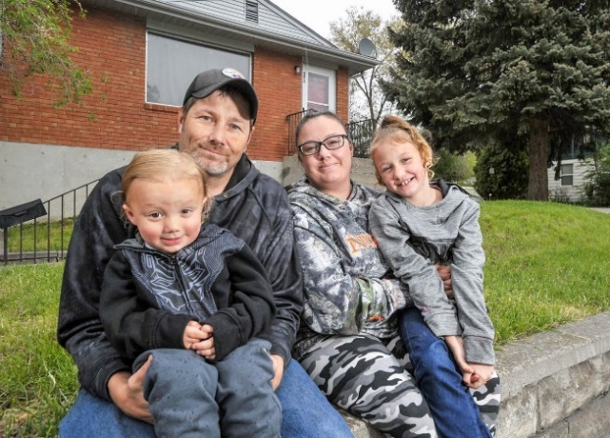 | The Face of Homelessness in Okanogan County.  Why are people homeless?  Reason #1: Lack of affordable housing.  Okanogan County is facing a housing crisis that contributes to homelessness. Free-market housing rates over the past few years have skyrocketed, pushing people living in the margins into homelessness. Okanogan needs over 2,000 more low-income housing units to meet the demand. | Learn more from the partners of the Okanogan County Housing Coalition at www.occac.com/livingwithouthousing
1-4-23 |  | Face of Homelessness in Okanogan County  Why are people homeless?  Reason #2: Poverty  Difficult choices must be made when limited resources cover only some of these necessities. Housing absorbs a high proportion of income. If you are low income, you are one illness, accident, or paycheck away from living on the streets. Between 20-25 percent of Okanogan County residents live in poverty. Okanogan needs more living-wage jobs to support its population. | Learn more from the partners of the Okanogan County Housing Coalition at www.occac.com/livingwithouthousing
1-11-23 | 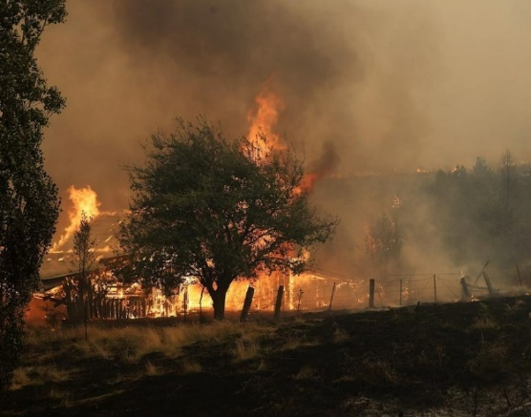 | The Face of Homelessness in Okanogan County  Why are people homeless?  Reason #3: Wildfire  Persistent wildfires over several years in Okanogan County leaves hundreds of residents without permanent housing. Most off-the-grid homes located in or near wild lands cannot be covered by insurance. When wildfire claims homes, recovery can take years or never for some. Okanogan needs more emergency shelter for people displaced by natural disasters. | Learn more from the partners of the Okanogan County Housing Coalition at www.occac.com/livingwithouthousing
1-18-23 |  | The Face of Homelessness in Okanogan County  Why are people homeless?  Reason #4: Lack of Living-Wage Jobs  A significant portion of homeless people have jobs but don’t earn enough to afford the cost of rent. Some may be on a fixed income like social security or a pension, but the amount isn’t enough to pay rent. Others may want to work but can’t get hired because they don’t have an address, lack clean clothes or a place to wash up, or face stigma due to their homelessness. | Learn more from the partners of the Okanogan County Housing Coalition at www.occac.com/livingwithouthousing
1-25-23 |  | The Face of Homelessness in Okanogan County: MYTHS & FACTS  MYTH: Most homeless people have a mental illness.  FACT: About one-third of people living without housing have a serious mental illness that may limit their ability to hold a job, or successfully maintain a residence. | Learn more from the partners of the Okanogan County Housing Coalition at www.occac.com/livingwithouthousing
2-1-23 | 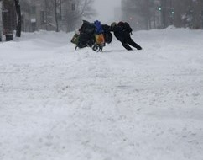 | The Face of Homelessness in Okanogan County: MYTHS & FACTS  MYTH: Homeless people are dangerous and violent.  FACT: Homeless people are far more likely to be victims of crime than perpetrators. Some homeless may commit acts of violence beyond self-defense, but such acts rarely affect non-homeless individuals. Rare occurrences of violence by homeless individuals usually are an act of self-defense or committed on other homeless individuals. | Learn more from the partners of the Okanogan County Housing Coalition at www.occac.com/livingwithouthousing
2-8-28 |  | The Face of Homelessness in Okanogan County: MYTHS & FACTS  MYTH: Homeless people are to blame for theft and crime.  FACT: Homeless people are more likely to have interactions with law enforcement because most of their daily survival activities are criminalized. They might be arrested for trespassing or loitering. | Learn more from the partners of the Okanogan County Housing Coalition at www.occac.com/livingwithouthousing
2-15-23 | 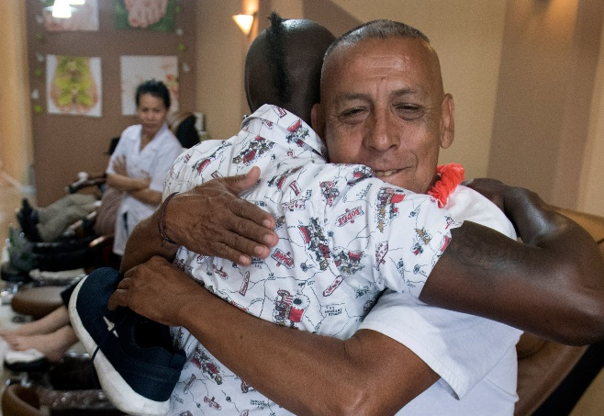 | The Face of Homelessness in Okanogan County: MYTHS & FACTS  MYTH: Bad choices lead to homelessness.  FACT: The descent into homelessness is not necessarily from a series of bad choices. More often, a sudden illness or accident, loss of job or falling into debt leads to eviction and doubling up with family or friends becomes an untenable situation. | Learn more from the partners of the Okanogan County Housing Coalition at www.occac.com/livingwithouthousing
2-22-23 | 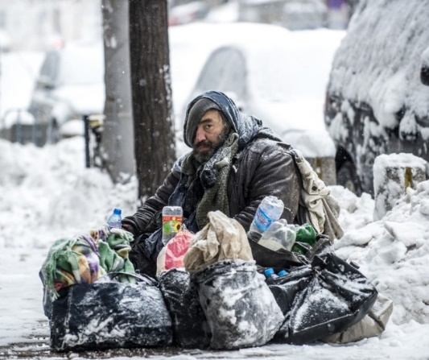 | The Face of Homelessness in Okanogan County: MYTHS & FACTS  MYTH: Homeless people prefer the freedom of living on the streets.  FACT: Though some individuals find it challenging to receive services, most will accept and welcome an offer of housing or shelter when it’s offered. People on the streets reject the idea of crowded, unsafe shelters. | Learn more from the partners of the Okanogan County Housing Coalition at www.occac.com/livingwithouthousing
3-1-23 | 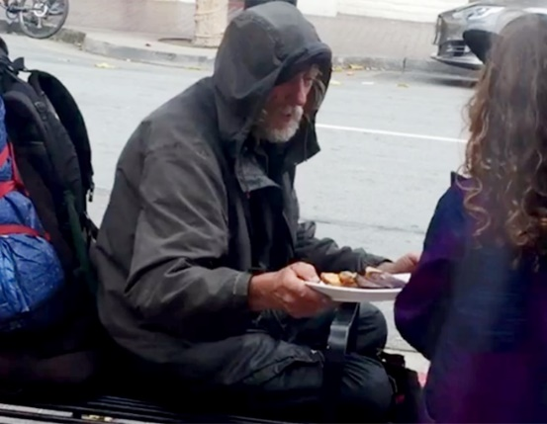 | The Face of Homelessness in Okanogan County: MYTHS & FACTS  MYTH: Homeless people just spend money on drugs and alcohol.  FACT: Interviews with street people show that most of their money goes to buy food and amenities such as socks, hygiene products, and bottled water. Although some spend money on alcohol and drugs, the same can be said of anyone else. | Learn more from the partners of the Okanogan County Housing Coalition at www.occac.com/livingwithouthousing
3-8-23 | 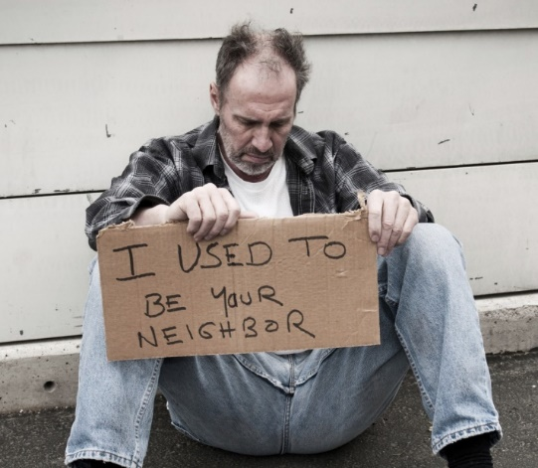 | The Face of Homelessness in Okanogan County: MYTHS & FACTS  MYTH: The homeless are not part of our community.  FACT: Between 70-80 percent of homeless people are from the local area or have lived here for over a year before becoming homeless. | Learn more from the partners of the Okanogan County Housing Coalition at www.occac.com/livingwithouthousing
3-15-23 | 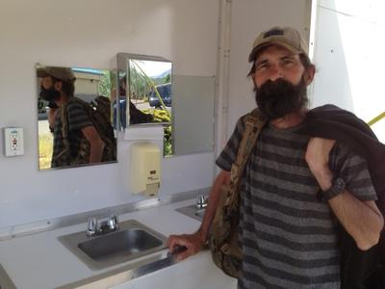 | The Face of Homelessness in Okanogan County: MYTHS & FACTS  MYTH: The homeless live in unsanitary conditions because they don’t care.  FACT: Living outside limits regular access to places to bathe, use the toilet, dispose of trash, and store food safety. Lacking access to a shower is one of the most humiliating aspects of being homeless. | Learn more from the partners of the Okanogan County Housing Coalition at www.occac.com/livingwithouthousing
3-22-23 | 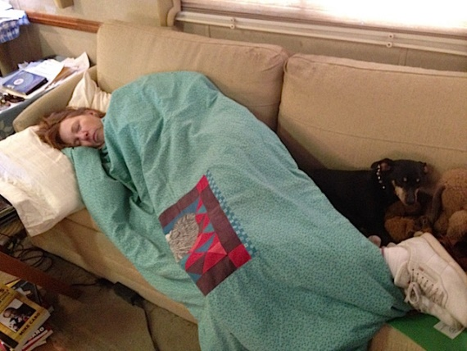 | The Face of Homelessness in Okanogan County: MYTHS & FACTS  MYTH: Youth are not homeless if they have a couch to sleep on.  FACT: A couch surfing teen may not fit the stereotype of what a homeless person looks like, but couch surfing is a common form of homelessness, Over 30% of all people living in homelessness are under the age of 24. A disproportionate number of young people experiencing homelessness are youth of color, gay, lesbian, bisexual or transgender. | Learn more from the partners of the Okanogan County Housing Coalition at www.occac.com/livingwithouthousing
3-29-23 | 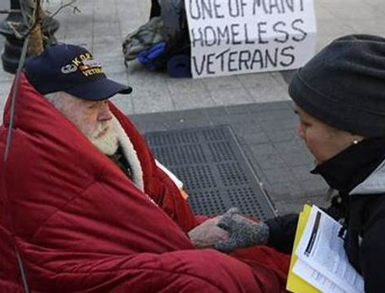 | The Face of Homelessness in Okanogan County  Why are veterans homeless?  Circumstance.  About 50% of all homeless veterans are living with a disability including Post Traumatic Stress Syndrome (PTSD), traumatic brain injury, and other mental health and physical disabilities. Other factors in their homelessness include poverty, unemployment after discharge, unaffordable housing, substance abuse, and intimate partner violence. About 7% of people living in Okanogan are military veterans. | Learn more from the partners of the Okanogan County Housing Coalition at www.occac.com/livingwithouthousing
4-5-22 | 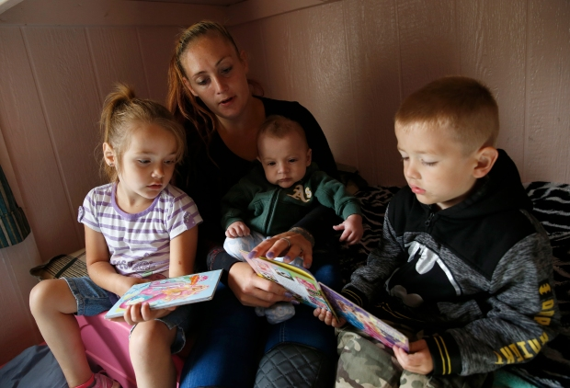 | The Face of Homelessness in Okanogan County  Why are women homeless?  Domestic Violence.  Domestic violence is the leading cause of homelessness among women. Nearly 40% of all domestic violence victims become homeless at some point in their lives. Many abused women don’t have strong support systems they can rely on and must seek supportive housing and resources from other social service agencies. Many women escaping abuse rather live in a shelter or on the streets than stay trapped in a consistently violent home. | Learn more from the partners of the Okanogan County Housing Coalition at www.occac.com/livingwithouthousing
4-14-22 | 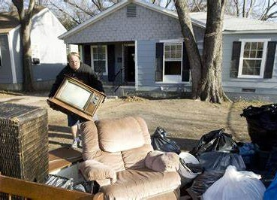 | The Face of Homelessness in Okanogan County  What is the community doing to prevent homelessness?  Members of the Okanogan County Housing Coalition participate in what is called Rapid-Rehousing which helps homeless people find permanent housing. Rapid-Rehousing connects families and individuals experiencing homelessness to permanent housing while working with them on a tailored package of assistance that may include temporarily covering rent, utilities, and moving costs while also teaching skills for staying out of homelessness like financial literacy. | Learn more from the partners of the Okanogan County Housing Coalition at www.occac.com/livingwithouthousing
4-21-23 |  | The Face of Homelessness in Okanogan County  What is our community doing to prevent homelessness?  It’s very difficult to find a job or attend to mental health or substance abuse issues if you don’t have food or a place to live. Members of the Okanogan County Housing Coalition are guided by the Housing First homeless assistance approach that prioritizes permanent housing to people experiencing homelessness, thus ending their homelessness, and giving them stability to pursue personal goals and improve their quality of life. | Learn more from the partners of the Okanogan County Housing Coalition at www.occac.com/livingwithouthousing

